Table 3 The perturbation bounds used in the eFAST global sensitivity analysis for each station
Meteorological Station | Maximum Temperature (℃) | Minimum Temperature (℃) | Relative Humidity (%) | Solar Radiation (MJ m⁻² day⁻¹) | Wind Speed (m/s)
Alor Setar | 24.10 – 39.10 | 19.20 – 27.70 | 19.20 – 27.70 | 0.00 – 27.69 | 0.10 – 4.70
Pulau Langkawi | 25.70 – 38.00 | 19.20 – 27.70 | 49.80 – 98.30 | 0.00 – 27.69 | 0.10 – 4.70
Bayan Lepas | 24.40 – 37.90 | 19.80 – 29.20 | 45.70 – 96.50 | 0.16 – 31.50 | 0.20 – 6.10
Ipoh | 24.30 – 37.50 | 19.40 – 27.00 | 7.30 – 98.40 | 1.61 – 27.01 | 0.00 – 4.40
Sitiawan | 23.90 – 36.40 | 19.20 – 27.60 | 67.80 – 98.00 | 0.00 – 26.15 | 0.00 – 2.90
Lubok Merbau | 23.80 – 38.30 | 17.20 – 26.80 | 49.90 – 96.30 | 0.23 – 27.55 | 0.10 – 4.80
Cameron Highlands | 16.50 – 36.00 | 10.90 – 29.20 | 45.80 – 99.90 | 0.55 – 33.57 | 0.10 – 8.60
Kuantan | 23.00 – 37.30 | 18.80 – 27.30 | 64.90 – 99.70 | 0.00 – 29.66 | 0.00 – 4.00
Muadzam Shah | 23.00 – 37.70 | 18.90 – 26.40 | 63.70 – 98.70 | 0.00 – 188.92 | 0.10 – 4.30
Kota Bharu | 23.80 – 35.90 | 17.80 – 27.90 | 61.90 – 98.60 | 0.07 – 28.90 | 0.40 – 27.80
Kuala Terengganu | 23.80 – 34.90 | 19.30 – 28.20 | 57.50 – 98.20 | 0.00 – 27.68 | 0.10 – 7.70
KLIA Sepang | 24.20 – 37.40 | 20.30 – 27.70 | 49.30 – 98.70 | 1.06 – 31.60 | 0.00 – 6.30
Subang | 24.60 – 37.90 | 21.10 – 28.10 | 52.70 – 96.30 | 0.81 – 35.97 | 0.20 – 4.40
Kuching | 23.60 – 37.30 | 19.60 – 26.40 | 8.70 – 98.10 | 0.37 – 26.71 | 0.10 – 4.10
Miri | 24.80 – 35.80 | 20.50 – 27.00 | 64.10 – 97.40 | 0.62 – 29.28 | 0.20 – 5.40
Sibu | 23.50 – 37.00 | 19.50 – 26.30 | 65.70 – 97.70 | 0.37 – 26.71 | 0.10 – 3.50
Sandakan | 23.90 – 36.10 | 20.10 – 27.80 | 8.30 – 99.60 | 0.99 – 28.68 | 0.10 – 7.60
Labuan | 25.00 – 35.50 | 21.20 – 28.60 | 61.10 – 97.20 | 0.99 – 28.68 | 0.20 – 7.20
Kota Kinabalu | 23.10 – 36.50 | 19.50 – 27.40 | 57.70 – 96.60 | 0.99 – 28.68 | 0.20 – 6.30
Tawau | 24.70 – 36.00 | 18.70 – 26.40 | 58.20 – 96.90 | 0.99 – 36.60 | 0.00 – 4.40

Table 4 OAT Sensitivity
Meteorological Station | Maximum Temperature | Minimum Temperature | Wind Speed | Relative Humidity | Solar Radiation
Alor Setar | 0.508 | 0.257 | 0.078 | 0.621 | 0.712
Pulau Langkawi | 0.496 | 0.281 | 0.106 | 0.676 | 0.663
Bayan Lepas | 0.494 | 0.273 | 0.098 | 0.676 | 0.680
Ipoh | 0.511 | 0.253 | 0.077 | 0.546 | 0.725
Sitiawan | 0.473 | 0.254 | 0.050 | 0.442 | 0.768
Lubok Merbau | 0.503 | 0.246 | 0.065 | 0.501 | 0.742
Cameron Highlands | 0.395 | 0.219 | 0.041 | 0.941 | 0.680
Kuantan | 0.494 | 0.263 | 0.048 | 0.633 | 0.749
Muadzam Shah | 0.462 | 0.240 | 0.035 | 0.269 | 0.797
Kota Bharu | 0.524 | 0.290 | 0.124 | 1.046 | 0.601
Kuala Terengganu | 0.472 | 0.272 | 0.084 | 0.818 | 0.684
KLIA Sepang | 0.497 | 0.264 | 0.096 | 0.666 | 0.685
Subang | 0.501 | 0.254 | 0.103 | 0.547 | 0.699
Kuching | 0.476 | 0.251 | 0.063 | 0.790 | 0.718
Miri | 0.485 | 0.275 | 0.070 | 0.869 | 0.696
Sibu | 0.489 | 0.249 | 0.060 | 0.703 | 0.731
Sandakan | 0.493 | 0.281 | 0.077 | 0.830 | 0.692
Labuan | 0.476 | 0.290 | 0.081 | 0.729 | 0.697
Kota Kinabalu | 0.515 | 0.268 | 0.088 | 0.753 | 0.687
Tawau | 0.490 | 0.267 | 0.056 | 0.661 | 0.727

Table 5 eFAST sensitivity analysis results for meteorological variables across 20 meteorological stations
Stations | Maximum Temperature |  | Minimum Temperature |  | WS |  | RH |  | SR
 | Si | STi | Si | STi | Si | STi | Si | STi | Si | STi
Alor Setar | 0.034 | 0.044 | 0.004 | 0.007 | 0.090 | 0.158 | 0.185 | 0.250 | 0.617 | 0.634
Pulau Langkawi | 0.027 | 0.035 | 0.006 | 0.009 | 0.142 | 0.239 | 0.388 | 0.475 | 0.327 | 0.343
Bayan Lepas | 0.022 | 0.029 | 0.005 | 0.008 | 0.112 | 0.189 | 0.229 | 0.302 | 0.555 | 0.573
Ipoh | 0.020 | 0.027 | 0.002 | 0.004 | 0.274 | 0.413 | 0.317 | 0.463 | 0.224 | 0.243
Sitiawan | 0.013 | 0.019 | 0.004 | 0.007 | 0.015 | 0.037 | 0.038 | 0.058 | 0.890 | 0.904
Lubok Merbau | 0.027 | 0.036 | 0.004 | 0.007 | 0.107 | 0.178 | 0.187 | 0.251 | 0.574 | 0.592
Cameron Highlands | 0.065 | 0.082 | 0.023 | 0.030 | 0.079 | 0.182 | 0.341 | 0.444 | 0.366 | 0.390
Kuantan | 0.026 | 0.035 | 0.004 | 0.006 | 0.017 | 0.055 | 0.070 | 0.102 | 0.856 | 0.874
Muadzam Shah | 0.007 | 0.009 | 0.001 | 0.002 | 0.011 | 0.020 | 0.001 | 0.002 | 0.970 | 0.981
Kota Bahru | 0.033 | 0.044 | 0.010 | 0.015 | 0.083 | 0.200 | 0.628 | 0.726 | 0.125 | 0.146
Kuala Terengganu | 0.016 | 0.022 | 0.005 | 0.008 | 0.091 | 0.179 | 0.290 | 0.374 | 0.513 | 0.531
KLIA Sepang | 0.029 | 0.037 | 0.003 | 0.005 | 0.093 | 0.183 | 0.227 | 0.312 | 0.556 | 0.574
Subang | 0.019 | 0.025 | 0.004 | 0.005 | 0.037 | 0.076 | 0.084 | 0.117 | 0.795 | 0.810
Kuching | 0.019 | 0.025 | 0.002 | 0.003 | 0.243 | 0.365 | 0.319 | 0.450 | 0.274 | 0.294
Miri | 0.021 | 0.027 | 0.003 | 0.006 | 0.037 | 0.087 | 0.128 | 0.168 | 0.751 | 0.768
Sibu | 0.019 | 0.026 | 0.008 | 0.004 | 0.023 | 0.052 | 0.066 | 0.092 | 0.839 | 0.854
Sandakan | 0.015 | 0.022 | 0.002 | 0.005 | 0.257 | 0.400 | 0.455 | 0.601 | 0.121 | 0.133
Labuan | 0.015 | 0.020 | 0.004 | 0.007 | 0.072 | 0.146 | 0.230 | 0.296 | 0.579 | 0.597
Kota Kinabalu | 0.028 | 0.036 | 0.005 | 0.007 | 0.080 | 0.151 | 0.215 | 0.280 | 0.575 | 0.593
Tawau | 0.014 | 0.018 | 0.003 | 0.005 | 0.022 | 0.058 | 0.062 | 0.091 | 0.843 | 0.859

T

Table 6(a) Statistical metrics results for SVR-CMAES model
 |  | SVR-CMAES
 |  | C1 |  |  | C2 |  |  | C3 |  |  | C4
 |  | Train | Val | Test | Train | Val | Test | Train | Val | Test | Train | Val | Test
Alor Setar | MAE | 0.566 | 0.533 | 0.462 | 0.334 | 0.280 | 0.290 | 0.172 | 0.206 | 0.194 | 0.148 | 0.129 | 0.135
 | RMSE | 0.693 | 0.651 | 0.572 | 0.405 | 0.351 | 0.350 | 0.206 | 0.242 | 0.232 | 0.186 | 0.167 | 0.170
 | R² | 0.538 | 0.617 | 0.679 | 0.842 | 0.888 | 0.880 | 0.959 | 0.947 | 0.947 | 0.967 | 0.975 | 0.972
 | d1 | 0.591 | 0.629 | 0.673 | 0.777 | 0.814 | 0.803 | 0.891 | 0.867 | 0.872 | 0.912 | 0.923 | 0.918
 | KGE | 0.591 | 0.643 | 0.678 | 0.745 | 0.773 | 0.773 | 0.866 | 0.860 | 0.864 | 0.980 | 0.985 | 0.977
 | GPI | 0.684 | 0.723 | 0.757 | 0.864 | 0.900 | 0.893 | 0.961 | 0.949 | 0.950 | 0.968 | 0.975 | 0.972
 |  | Good | Good | Good | Excel | Excel | Excel | Excel | Excel | Excel | Excel | Excel | Excel
Pulau Langkawi | MAE | 0.472 | 0.500 | 0.509 | 0.378 | 0.367 | 0.439 | 0.201 | 0.155 | 0.195 | 0.172 | 0.188 | 0.200
 | RMSE | 0.599 | 0.637 | 0.636 | 0.475 | 0.454 | 0.518 | 0.244 | 0.191 | 0.238 | 0.216 | 0.236 | 0.246
 | R² | 0.705 | 0.673 | 0.699 | 0.815 | 0.934 | 0.801 | 0.951 | 0.971 | 0.958 | 0.962 | 0.955 | 0.955
 | d1 | 0.702 | 0.688 | 0.691 | 0.755 | 0.774 | 0.733 | 0.883 | 0.910 | 0.889 | 0.901 | 0.892 | 0.891
 | KGE | 0.772 | 0.759 | 0.738 | 0.713 | 0.755 | 0.703 | 0.916 | 0.906 | 0.877 | 0.960 | 0.947 | 0.961
 | GPI | 0.772 | 0.754 | 0.769 | 0.844 | 0.849 | 0.834 | 0.953 | 0.972 | 0.960 | 0.963 | 0.957 | 0.967
 |  | VG | VG | VG | VG | VG | VG | Excel | Excel | Excel | Excel | Excel | Excel
Bayan Lepas | MAE | 0.576 | 0.681 | 0.578 | 0.474 | 0.426 | 0.492 | 0.151 | 0.160 | 0.180 | 0.147 | 0.143 | 0.167
 | RMSE | 0.745 | 0.886 | 0.759 | 0.518 | 0.469 | 0.536 | 0.198 | 0.215 | 0.231 | 0.181 | 0.177 | 0.211
 | R² | 0.468 | 0.360 | 0.516 | 0.744 | 0.821 | 0.758 | 0.953 | 0.962 | 0.955 | 0.969 | 0.974 | 0.963
 | d1 | 0.578 | 0.523 | 0.583 | 0.719 | 0.759 | 0.721 | 0.907 | 0.907 | 0.895 | 0.906 | 0.914 | 0.898
 | KGE | 0.544 | 0.469 | 0.531 | 0.851 | 0.862 | 0.847 | 0.941 | 0.930 | 0.950 | 0.894 | 0.885 | 0.890
 | GPI | 0.653 | 0.610 | 0.674 | 0.796 | 0.848 | 0.805 | 0.964 | 0.964 | 0.957 | 0.969 | 0.975 | 0.964
 |  | Med | Med | Good | VG | VG | VG | Excel | Excel | Excel | Excel | Excel | Excel
Ipoh | MAE | 0.327 | 0.320 | 0.353 | 0.192 | 0.144 | 0.145 | 0.126 | 0.122 | 0.125 | 0.109 | 0.107 | 0.113
 | RMSE | 0.407 | 0.408 | 0.443 | 0.216 | 0.176 | 0.176 | 0.158 | 0.157 | 0.160 | 0.138 | 0.176 | 0.146
 | R² | 0.705 | 0.728 | 0.704 | 0.917 | 0.950 | 0.954 | 0.956 | 0.960 | 0.961 | 0.966 | 0.950 | 0.968
 | d1 | 0.695 | 0.710 | 0.686 | 0.836 | 0.882 | 0.882 | 0.891 | 0.900 | 0.899 | 0.904 | 0.882 | 0.908
 | KGE | 0.764 | 0.739 | 0.712 | 0.911 | 0.901 | 0.905 | 0.940 | 0.934 | 0.917 | 0.910 | 0.901 | 0.894
 | GPI | 0.772 | 0.786 | 0.772 | 0.917 | 0.952 | 0.956 | 0.956 | 0.961 | 0.963 | 0.967 | 0.952 | 0.969
 |  | VG | VG | VG | Excel | Excel | Excel | Excel | Excel | Excel | Excel | Excel | Excel
Lubok Merbau | MAE | 0.592 | 0.410 | 0.413 | 0.218 | 0.157 | 0.157 | 0.145 | 0.120 | 0.119 | 0.124 | 0.010 | 0.092
 | RMSE | 0.734 | 0.509 | 0.507 | 0.267 | 0.195 | 0.199 | 0.187 | 0.173 | 0.154 | 0.163 | 0.139 | 0.121
 | R² | 0.365 | 0.556 | 0.618 | 0.916 | 0.935 | 0.941 | 0.959 | 0.959 | 0.965 | 0.969 | 0.967 | 0.978
 | d1 | 0.537 | 0.655 | 0.663 | 0.850 | 0.855 | 0.944 | 0.906 | 0.900 | 0.909 | 0.920 | 0.916 | 0.929
 | KGE | 0.477 | 0.771 | 0.748 | 0.780 | 0.772 | 0.867 | 0.938 | 0.943 | 0.977 | 0.937 | 0.946 | 0.978
 | GPI | 0.612 | 0.692 | 0.723 | 0.923 | 0.939 | 0.786 | 0.960 | 0.951 | 0.966 | 0.970 | 0.948 | 0.979
 |  | Med | Good | Good | Excel | Excel | Excel | Excel | Excel | Excel | Excel | Excel | Excel
Sitiawan | MAE | 0.438 | 0.399 | 0.397 | 0.126 | 0.116 | 0.107 | 0.111 | 0.104 | 0.095 | 0.126 | 0.109 | 0.107
 | RMSE | 0.531 | 0.486 | 0.493 | 0.154 | 0.146 | 0.134 | 0.141 | 0.141 | 0.131 | 0.161 | 0.145 | 0.142
 | R² | 0.508 | 0.681 | 0.645 | 0.959 | 0.971 | 0.974 | 0.965 | 0.973 | 0.975 | 0.956 | 0.982 | 0.971
 | d1 | 0.585 | 0.659 | 0.636 | 0.900 | 0.918 | 0.919 | 0.911 | 0.926 | 0.927 | 0.896 | 0.921 | 0.915
 | KGE | 0.583 | 0.638 | 0.620 | 0.959 | 0.936 | 0.941 | 0.965 | 0.939 | 0.948 | 0.911 | 0.904 | 0.892
 | GPI | 0.670 | 0.758 | 0.738 | 0.960 | 0.972 | 0.974 | 0.967 | 0.974 | 0.976 | 0.957 | 0.973 | 0.971
 |  | Good | Good | Good | Excel | Excel | Excel | Excel | Excel | Excel | Excel | Excel | Excel
Cameron Highlands | MAE | 0.408 | 0.478 | 0.420 | 0.101 | 0.100 | 0.095 | 0.148 | 0.153 | 0.147 | 0.078 | 0.077 | 0.076
 | RMSE | 0.536 | 0.560 | 0.554 | 0.138 | 0.156 | 0.155 | 0.171 | 0.189 | 0.169 | 0.108 | 0.106 | 0.106
 | R² | 0.531 | 0.542 | 0.541 | 0.969 | 0.968 | 0.964 | 0.953 | 0.968 | 0.957 | 0.981 | 0.983 | 0.983
 | d1 | 0.603 | 0.620 | 0.631 | 0.970 | 0.931 | 0.929 | 0.881 | 0.904 | 0.894 | 0.931 | 0.941 | 0.941
 | KGE | 0.630 | 0.601 | 0.592 | 0.969 | 0.976 | 0.975 | 0.915 | 0.947 | 0.911 | 0.926 | 0.939 | 0.938
 | GPI | 0.681 | 0.687 | 0.685 | 0.967 | 0.967 | 0.966 | 0.955 | 0.969 | 0.956 | 0.981 | 0.985 | 0.984
 |  | Good | Good | Good | Excel | Excel | Excel | Excel | Excel | Excel | Excel | Excel | Excel
Kuantan | MAE | 0.448 | 0.586 | 0.585 | 0.161 | 0.173 | 0.172 | 0.133 | 0.186 | 0.187 | 0.119 | 0.175 | 0.174
 | RMSE | 0.579 | 0.748 | 0.747 | 0.200 | 0.225 | 0.224 | 0.165 | 0.2299 | 0.230 | 0.153 | 0.230 | 0.229
 | R² | 0.616 | 0.449 | 0.448 | 0.954 | 0.953 | 0.950 | 0.969 | 0.950 | 0.948 | 0.973 | 0.949 | 0.948
 | d1 | 0.668 | 0.570 | 0.569 | 0.887 | 0.888 | 0.885 | 0.907 | 0.972 | 0.973 | 0.919 | 0.884 | 0.883
 | KGE | 0.700 | 0.610 | 0.567 | 0.855 | 0.853 | 0.851 | 0.872 | 0.850 | 0.845 | 0.911 | 0.836 | 0.835
 | GPI | 0.723 | 0.651 | 0.644 | 0.956 | 0.954 | 0.953 | 0.970 | 0.951 | 0.950 | 0.974 | 0.951 | 0.951
 |  | Good | Med | Med | Excel | Excel | Excel | Excel | Excel | Excel | Excel | Excel | Excel
Muadzam Shah | MAE | 0.368 | 0.65 | 0.653 | 0.149 | 0.150 | 0.151 | 0.149 | 0.220 | 0.224 | 0.141 | 0.219 | 0.218
 | RMSE | 0.460 | 0.830 | 0.825 | 0.185 | 0.187 | 0.189 | 0.181 | 0.272 | 0.273 | 0.172 | 0.264 | 0.264
 | R² | 0.712 | 0.350 | 0.322 | 0.954 | 0.960 | 0.965 | 0.955 | 0.930 | 0.926 | 0.960 | 0.932 | 0.931
 | d1 | 0.700 | 0.511 | 0.509 | 0.882 | 0.893 | 0.897 | 0.878 | 0.849 | 0.841 | 0.885 | 0.950 | 0.945
 | KGE | 0.770 | 0.653 | 0.529 | 0.849 | 0.840 | 0.837 | 0.791 | 0.780 | 0.770 | 0.818 | 0.785 | 0.781
 | GPI | 0.776 | 0.615 | 0.596 | 0.956 | 0.960 | 0.966 | 0.949 | 0.944 | 0.931 | 0.961 | 0.936 | 0.935
 |  | VG | Bear | Bear | Excel | Excel | Excel | Excel | Excel | Excel | Excel | Excel | Excel
Kota Bharu | MAE | 0.639 | 0.551 | 0.502 | 0.224 | 0.223 | 0.222 | 0.125 | 0.129 | 0.130 | 0.117 | 0.119 | 0.104
 | RMSE | 0.846 | 0.759 | 0.630 | 0.285 | 0.291 | 0.292 | 0.165 | 0.173 | 0.178 | 0.158 | 0.160 | 0.146
 | R² | 0.370 | 0.504 | 0.627 | 0.928 | 0.929 | 0.920 | 0.976 | 0.972 | 0.970 | 0.978 | 0.981 | 0.980
 | d1 | 0.433 | 0.559 | 0.614 | 0.864 | 0.865 | 0.850 | 0.928 | 0.925 | 0.920 | 0.928 | 0.930 | 0.932
 | KGE | 0.486 | 0.534 | 0.650 | 0.964 | 0.939 | 0.937 | 0.986 | 0.971 | 0.967 | 0.900 | 0.909 | 0.905
 | GPI | 0.614 | 0.714 | 0.728 | 0.933 | 0.925 | 0.920 | 0.976 | 0.975 | 0.971 | 0.978 | 0.979 | 0.980
 |  | Med | Good | Good | Excel | Excel | Excel | Excel | Excel | Excel | Excel | Excel | Excel
Kuala Terengganu | MAE | 0.609 | 0.691 | 0.812 | 0.219 | 0.222 | 0.214 | 0.102 | 0.129 | 0.128 | 0.090 | 0.123 | 0.124
 | RMSE | 0.735 | 0.823 | 0.939 | 0.260 | 0.268 | 0.261 | 0.136 | 0.185 | 0.183 | 0.108 | 0.174 | 0.175
 | R² | 0.286 | 0.242 | 0.209 | 0.911 | 0.920 | 0.939 | 0.976 | 0.973 | 0.970 | 0.985 | 0.974 | 0.973
 | d1 | 0.420 | 0.418 | 0.414 | 0.836 | 0.852 | 0.870 | 0.924 | 0.923 | 0.923 | 0.937 | 0.928 | 0.927
 | KGE | 0.341 | 0.335 | 0.363 | 0.923 | 0.900 | 0.899 | 0.973 | 0.969 | 0.952 | 0.933 | 0.984 | 0.985
 | GPI | 0.583 | 0.569 | 0.558 | 0.818 | 0.926 | 0.942 | 0.976 | 0.973 | 0.971 | 0.985 | 0.974 | 0.973
 |  | Bear | Bear | Bear | VG | Excel | Excel | Excel | Excel | Excel | Excel | Excel | Excel
KLIA Sepang | MAE | 0.464 | 0.475 | 0.386 | 0.321 | 0.289 | 0.294 | 0.130 | 0.119 | 0.120 | 0.143 | 0.126 | 0.123
 | RMSE | 0.584 | 0.564 | 0.489 | 0.379 | 0.355 | 0.349 | 0.177 | 0.169 | 0.163 | 0.187 | 0.176 | 0.161
 | R² | 0.627 | 0.672 | 0.723 | 0.844 | 0.882 | 0.859 | 0.966 | 0.974 | 0.969 | 0.962 | 0.971 | 0.970
 | d1 | 0.662 | 0.663 | 0.709 | 0.774 | 0.808 | 0.787 | 0.914 | 0.927 | 0.921 | 0.905 | 0.922 | 0.917
 | KGE | 0.701 | 0.667 | 0.743 | 0.787 | 0.779 | 0.789 | 0.951 | 0.962 | 0.958 | 0.943 | 0.945 | 0.962
 | GPI | 0.729 | 0.753 | 0.783 | 0.865 | 0.895 | 0.877 | 0.967 | 0.974 | 0.970 | 0.963 | 0.972 | 0.971
 |  | Good | Good | VG | Excel | Excel | Excel | Excel | Excel | Excel | Excel | Excel | Excel
Subang | MAE | 0.436 | 0.365 | 0.364 | 0.156 | 0.158 | 0.159 | 0.133 | 0.128 | 0.121 | 0.164 | 0.156 | 0.149
 | RMSE | 0.544 | 0.490 | 0.489 | 0.186 | 0.189 | 0.190 | 0.165 | 0.159 | 0.157 | 0.203 | 0.199 | 0.192
 | R² | 0.663 | 0.695 | 0.691 | 0.961 | 0.959 | 0.953 | 0.967 | 0.968 | 0.968 | 0.953 | 0.952 | 0.952
 | d1 | 0.680 | 0.715 | 0.720 | 0.894 | 0.890 | 0.883 | 0.875 | 0.911 | 0.908 | 0.868 | 0.870 | 0.884
 | KGE | 0.731 | 0.757 | 0.761 | 0.921 | 0.915 | 0.908 | 0.992 | 0.890 | 0.861 | 0.811 | 0.811 | 0.811
 | GPI | 0.748 | 0.765 | 0.764 | 0.962 | 0.960 | 0.955 | 0.906 | 0.960 | 0.969 | 0.955 | 0.955 | 0.955
 |  | Good | VG | VG | Excel | Excel | Excel | Excel | Excel | Excel | Excel | Excel | Excel
Kuching | MAE | 0.363 | 0.335 | 0.333 | 0.134 | 0.132 | 0.143 | 0.128 | 0.131 | 0.133 | 0.096 | 0.083 | 0.082
 | RMSE | 0.478 | 0.437 | 0.417 | 0.162 | 0.158 | 0.173 | 0.159 | 0.163 | 0.163 | 0.124 | 0.109 | 0.110
 | R² | 0.692 | 0.741 | 0.784 | 0.965 | 0.966 | 0.963 | 0.966 | 0.962 | 0.967 | 0.979 | 0.983 | 0.985
 | d1 | 0.711 | 0.726 | 0.745 | 0.898 | 0.894 | 0.896 | 0.900 | 0.893 | 0.900 | 0.929 | 0.936 | 0.942
 | KGE | 0.751 | 0.758 | 0.759 | 0.880 | 0.862 | 0.871 | 0.851 | 0.829 | 0.839 | 0.932 | 0.917 | 0.922
 | GPI | 0.765 | 0.794 | 0.822 | 0.966 | 0.966 | 0.964 | 0.967 | 0.964 | 0.968 | 0.980 | 0.983 | 0.985
 |  | VG | VG | VG | Excel | Excel | Excel | Excel | Excel | Excel | Excel | Excel | Excel
Miri | MAE | 0.596 | 0.495 | 0.447 | 0.153 | 0.146 | 0.140 | 0.128 | 0.115 | 0.110 | 0.108 | 0.099 | 0.091
 | RMSE | 0.736 | 0.666 | 0.551 | 0.187 | 0.177 | 0.175 | 0.158 | 0.142 | 0.139 | 0.141 | 0.129 | 0.121
 | R² | 0.375 | 0.497 | 0.578 | 0.960 | 0.959 | 0.957 | 0.971 | 0.972 | 0.973 | 0.977 | 0.979 | 0.980
 | d1 | 0.537 | 0.597 | 0.619 | 0.902 | 0.898 | 0.894 | 0.916 | 0.917 | 0.917 | 0.930 | 0.931 | 0.932
 | KGE | 0.482 | 0.515 | 0.630 | 0.913 | 0.897 | 0.877 | 0.903 | 0.911 | 0.913 | 0.921 | 0.922 | 0.923
 | GPI | 0.615 | 0.701 | 0.703 | 0.961 | 0.960 | 0.959 | 0.972 | 0.973 | 0.974 | 0.977 | 0.979 | 0.980
 |  | Med | Good | Good | Excel | Excel | Excel | Excel | Excel | Excel | Excel | Excel | Excel
Sibu | MAE | 0.484 | 0.470 | 0.450 | 0.093 | 0.092 | 0.081 | 0.084 | 0.081 | 0.072 | 0.081 | 0.076 | 0.072
 | RMSE | 0.619 | 0.571 | 0.543 | 0.119 | 0.119 | 0.104 | 0.109 | 0.108 | 0.094 | 0.105 | 0.097 | 0.091
 | R² | 0.446 | 0.552 | 0.606 | 0.979 | 0.981 | 0.986 | 0.983 | 0.984 | 0.988 | 0.984 | 0.987 | 0.989
 | d1 | 0.565 | 0.606 | 0.618 | 0.928 | 0.931 | 0.995 | 0.936 | 0.939 | 0.948 | 0.938 | 0.944 | 0.948
 | KGE | 0.532 | 0.597 | 0.595 | 0.926 | 0.920 | 0.866 | 0.941 | 0.931 | 0.945 | 0.945 | 0.946 | 0.952
 | GPI | 0.643 | 0.691 | 0.718 | 0.980 | 0.981 | 0.986 | 0.983 | 0.984 | 0.989 | 0.984 | 0.987 | 0.989
 |  | Med | Good | Good | Excel | Excel | Excel | Excel | Excel | Excel | Excel | Excel | Excel
Kota Kinabalu | MAE | 0.599 | 0.499 | 0.509 | 0.197 | 0.163 | 0.180 | 0.136 | 0.146 | 0.139 | 0.108 | 0.104 | 0.106
 | RMSE | 0.750 | 0.617 | 0.613 | 0.244 | 0.208 | 0.221 | 0.168 | 0.182 | 0.173 | 0.143 | 0.143 | 0.137
 | R² | 0.443 | 0.501 | 0.555 | 0.941 | 0.943 | 0.942 | 0.972 | 0.957 | 0.964 | 0.980 | 0.973 | 0.978
 | d1 | 0.581 | 0.632 | 0.624 | 0.880 | 0.876 | 0.866 | 0.922 | 0.895 | 0.906 | 0.937 | 0.924 | 0.926
 | KGE | 0.553 | 0.745 | 0.718 | 0.864 | 0.861 | 0.830 | 0.983 | 0.975 | 0.974 | 0.967 | 0.966 | 0.959
 | GPI | 0.642 | 0.667 | 0.692 | 0.944 | 0.946 | 0.945 | 0.973 | 0.957 | 0.966 | 0.980 | 0.974 | 0.978
 |  | Med | Good | Good | Excel | Excel | Excel | Excel | Excel | Excel | Excel | Excel | Excel
Sandakan | MAE | 0.687 | 0.700 | 0.703 | 0.265 | 0.259 | 0.247 | 0.178 | 0.166 | 0.165 | 0.180 | 0.157 | 0.156
 | RMSE | 0.816 | 0.820 | 0.823 | 0.300 | 0.294 | 0.286 | 0.228 | 0.211 | 0.209 | 0.230 | 0.195 | 0.193
 | R² | 0.284 | 0.333 | 0.351 | 0.903 | 0.914 | 0.927 | 0.944 | 0.959 | 0.958 | 0.943 | 0.965 | 0.964
 | d1 | 0.458 | 0.460 | 0.463 | 0.843 | 0.844 | 0.845 | 0.885 | 0.886 | 0.887 | 0.883 | 0.895 | 0.894
 | KGE | 0.357 | 0.421 | 0.439 | 0.922 | 0.899 | 0.893 | 0.828 | 0.820 | 0.819 | 0.815 | 0.827 | 0.826
 | GPI | 0.583 | 0.600 | 0.606 | 0.912 | 0.929 | 0.932 | 0.947 | 0.960 | 0.960 | 0.946 | 0.966 | 0.965
 |  | Bear | Bear | Bear | Excel | Excel | Excel | Excel | Excel | Excel | Excel | Excel | Excel
Tawau | MAE | 0.762 | 0.604 | 0.594 | 0.226 | 0.276 | 0.287 | 0.140 | 0.119 | 0.113 | 0.172 | 0.159 | 0.157
 | RMSE | 0.883 | 0.723 | 0.715 | 0.270 | 0.307 | 0.320 | 0.177 | 0.159 | 0.144 | 0.206 | 0.190 | 0.189
 | R² | 0.140 | 0.399 | 0.417 | 0.920 | 0.899 | 0.883 | 0.965 | 0.975 | 0.977 | 0.954 | 0.960 | 0.959
 | d1 | 0.303 | 0.429 | 0.431 | 0.874 | 0.830 | 0.826 | 0.910 | 0.990 | 0.992 | 0.887 | 0.890 | 0.891
 | KGE | 0.112 | 0.337 | 0.344 | 0.860 | 0.888 | 0.891 | 0.864 | 0.879 | 0.888 | 0.845 | 0.874 | 0.873
 | GPI | 0.538 | 0.629 | 0.632 | 0.926 | 0.899 | 0.895 | 0.967 | 0.977 | 0.977 | 0.956 | 0.960 | 0.961
 |  | Bear | Med | Med | Excel | Excel | Excel | Excel | Excel | Excel | Excel | Excel | Excel
Labuan | MAE | 0.714 | 0.526 | 0.548 | 0.144 | 0.169 | 0.174 | 0.106 | 0.107 | 0.107 | 0.054 | 0.051 | 0.050
 | RMSE | 0.877 | 0.655 | 0.685 | 0.179 | 0.189 | 0.193 | 0.141 | 0.140 | 0.140 | 0.079 | 0.096 | 0.096
 | R² | 0.242 | 0.286 | 0.306 | 0.969 | 0.955 | 0.945 | 0.980 | 0.975 | 0.969 | 0.994 | 0.990 | 0.986
 | d1 | 0.492 | 0.539 | 0.525 | 0.918 | 0.898 | 0.867 | 0.937 | 0.928 | 0.916 | 0.949 | 0.966 | 0.964
 | KGE | 0.381 | 0.540 | 0.550 | 0.978 | 0.953 | 0.948 | 0.956 | 0.953 | 0.950 | 0.996 | 0.980 | 0.979
 | GPI | 0.569 | 0.618 | 0.590 | 0.970 | 0.950 | 0.948 | 0.980 | 0.980 | 0.979 | 0.994 | 0.988 | 0.987
 |  | Bear | Med | Bear | Excel | Excel | Excel | Excel | Excel | Excel | Excel | Excel | Excel
Note: Bearable (Bear), Median (Med), Very Good (VG), Excellent (Excel)

Table 6(a) Statistical metrics results for SVR-GSA model
 |  | SVR-GSA
 |  | C1 |  |  | C2 |  |  | C3 |  |  | C4
 |  | Train | Val | Test | Train | Val | Test | Train | Val | Test | Train | Val | Test
Alor Setar | MAE | 0.664 | 0.550 | 0.522 | 0.155 | 0.144 | 0.158 | 0.119 | 0.134 | 0.145 | 0.097 | 0.115 | 0.111
 | RMSE | 0.804 | 0.681 | 0.638 | 0.278 | 0.249 | 0.236 | 0.148 | 0.176 | 0.180 | 0.119 | 0.148 | 0.131
 | R² | 0.378 | 0.560 | 0.601 | 0.926 | 0.944 | 0.945 | 0.979 | 0.918 | 0.968 | 0.986 | 0.980 | 0.983
 | d1 | 0.508 | 0.582 | 0.594 | 0.907 | 0.913 | 0.901 | 0.929 | 0.919 | 0.910 | 0.944 | 0.931 | 0.932
 | KGE | 0.475 | 0.577 | 0.579 | 0.940 | 0.959 | 0.966 | 0.979 | 0.976 | 0.967 | 0.954 | 0.965 | 0.977
 | GPI | 0.616 | 0.704 | 0.715 | 0.931 | 0.947 | 0.948 | 0.980 | 0.973 | 0.969 | 0.987 | 0.981 | 0.984
 |  | Med | Good | Good | Excel | Excel | Excel | Excel | Excel | Excel | Excel | Excel | Excel
Pulau Langkawi | MAE | 0.542 | 0.548 | 0.554 | 0.216 | 0.177 | 0.226 | 0.139 | 0.119 | 0.134 | 0.096 | 0.098 | 0.098
 | RMSE | 0.679 | 0.694 | 0.689 | 0.362 | 0.278 | 0.330 | 0.185 | 0.155 | 0.176 | 0.118 | 0.123 | 0.129
 | R² | 0.622 | 0.612 | 0.647 | 0.893 | 0.938 | 0.919 | 0.972 | 0.981 | 0.977 | 0.989 | 0.988 | 0.988
 | d1 | 0.644 | 0.647 | 0.652 | 0.874 | 0.900 | 0.875 | 0.920 | 0.932 | 0.926 | 0.947 | 0.956 | 0.948
 | KGE | 0.699 | 0.701 | 0.689 | 0.924 | 0.949 | 0.920 | 0.971 | 0.963 | 0.940 | 0.954 | 0.988 | 0.982
 | GPI | 0.726 | 0.720 | 0.739 | 0.903 | 0.941 | 0.925 | 0.973 | 0.981 | 0.977 | 0.989 | 0.988 | 0.988
 |  | Good | Good | Good | Excel | Excel | Excel | Excel | Excel | Excel | Excel | Excel | Excel
Bayan Lepas | MAE | 0.706 | 0.711 | 0.690 | 0.200 | 0.225 | 0.246 | 0.160 | 0.172 | 0.201 | 0.124 | 0.179 | 0.139
 | RMSE | 0.912 | 0.882 | 0.877 | 0.362 | 0.342 | 0.436 | 0.200 | 0.250 | 0.266 | 0.143 | 0.285 | 0.183
 | R² | 0.203 | 0.366 | 0.353 | 0.875 | 0.905 | 0.840 | 0.962 | 0.949 | 0.941 | 0.981 | 0.934 | 0.972
 | d1 | 0.497 | 0.444 | 0.494 | 0.875 | 0.893 | 0.853 | 0.901 | 0.900 | 0.882 | 0.928 | 0.897 | 0.920
 | KGE | 0.408 | 0.376 | 0.405 | 0.900 | 0.924 | 0.888 | 0.944 | 0.934 | 0.940 | 0.940 | 0.918 | 0.980
 | GPI | 0.557 | 0.612 | 0.607 | 0.889 | 0.913 | 0.862 | 0.962 | 0.951 | 0.944 | 0.981 | 0.938 | 0.973
 |  | Bear | Bear | Bear | Excel | Excel | Excel | Excel | Excel | Excel | Excel | Excel | Excel
Ipoh | MAE | 0.380 | 0.390 | 0.419 | 0.125 | 0.111 | 0.108 | 0.090 | 0.083 | 0.102 | 0.085 | 0.100 | 0.084
 | RMSE | 0.474 | 0.483 | 0.523 | 0.145 | 0.149 | 0.135 | 0.107 | 0.105 | 0.128 | 0.104 | 0.120 | 0.108
 | R² | 0.600 | 0.618 | 0.589 | 0.963 | 0.964 | 0.973 | 0.980 | 0.982 | 0.975 | 0.981 | 0.976 | 0.982
 | d1 | 0.630 | 0.628 | 0.511 | 0.894 | 0.910 | 0.915 | 0.928 | 0.934 | 0.924 | 0.981 | 0.924 | 0.935
 | KGE | 0.684 | 0.659 | 0.643 | 0.953 | 0.938 | 0.948 | 0.927 | 0.973 | 0.934 | 0.983 | 0.927 | 0.974
 | GPI | 0.714 | 0.724 | 0.709 | 0.964 | 0.965 | 0.974 | 0.980 | 0.982 | 0.976 | 0.981 | 0.977 | 0.983
 |  | Good | Good | Good | Excel | Excel | Excel | Excel | Excel | Excel | Excel | Excel | Excel
Lubok Merbau | MAE | 0.601 | 0.415 | 0.388 | 0.140 | 0.168 | 0.163 | 0.128 | 0.168 | 0.102 | 0.053 | 0.054 | 0.050
 | RMSE | 0.783 | 0.550 | 0.492 | 0.163 | 0.184 | 0.175 | 0.143 | 0.151 | 0.130 | 0.067 | 0.069 | 0.068
 | R² | 0.277 | 0.481 | 0.640 | 0.969 | 0.942 | 0.955 | 0.971 | 0.969 | 0.965 | 0.995 | 0.997 | 0.993
 | d1 | 0.547 | 0.632 | 0.680 | 0.914 | 0.862 | 0.878 | 0.954 | 0.962 | 0.949 | 0.967 | 0.969 | 0.962
 | KGE | 0.463 | 0.704 | 0.766 | 0.968 | 0.959 | 0.961 | 0.972 | 0.980 | 0.969 | 0.994 | 0.995 | 0.988
 | GPI | 0.580 | 0.649 | 0.735 | 0.970 | 0.945 | 0.955 | 0.983 | 0.995 | 0.978 | 0.995 | 0.997 | 0.993
 |  | Bear | Med | Good | Excel | Excel | Excel | Excel | Excel | Excel | Excel | Excel | Excel
Sitiawan | MAE | 0.480 | 0.475 | 0.431 | 0.114 | 0.118 | 0.117 | 0.091 | 0.084 | 0.078 | 0.038 | 0.052 | 0.043
 | RMSE | 0.577 | 0.588 | 0.533 | 0.142 | 0.143 | 0.145 | 0.108 | 0.109 | 0.096 | 0.048 | 0.0781 | 0.086
 | R² | 0.419 | 0.419 | 0.585 | 0.979 | 0.980 | 0.971 | 0.980 | 0.984 | 0.987 | 0.996 | 0.992 | 0.990
 | d1 | 0.536 | 0.536 | 0.572 | 0.924 | 0.524 | 0.929 | 0.929 | 0.941 | 0.941 | 0.971 | 0.963 | 0.967
 | KGE | 0.497 | 0.497 | 0.535 | 0.950 | 0.950 | 0.959 | 0.981 | 0.964 | 0.985 | 0.998 | 0.980 | 0.994
 | GPI | 0.633 | 0.633 | 0.707 | 0.975 | 0.976 | 0.967 | 0.980 | 0.986 | 0.987 | 0.996 | 0.992 | 0.989
 |  | Med | Med | Good | Excel | Excel | Excel | Excel | Excel | Excel | Excel | Excel | Excel
Cameron Highlands | MAE | 0.418 | 0.701 | 0.475 | 0.086 | 0.087 | 0.090 | 0.100 | 0.198 | 0.101 | 0.076 | 0.232 | 0.084
 | RMSE | 0.555 | 0.881 | 0.630 | 0.105 | 0.203 | 0.125 | 0.118 | 0.363 | 0.124 | 0.094 | 0.413 | 0.118
 | R² | 0.495 | 0.291 | 0.405 | 0.982 | 0.963 | 0.977 | 0.977 | 0.880 | 0.977 | 0.986 | 0.986 | 0.979
 | d1 | 0.583 | 0.498 | 0.592 | 0.926 | 0.897 | 0.930 | 0.914 | 0.874 | 0.923 | 0.936 | 0.937 | 0.939
 | KGE | 0.609 | 0.475 | 0.571 | 0.977 | 0.965 | 0.970 | 0.970 | 0.837 | 0.968 | 0.945 | 0.945 | 0.958
 | GPI | 0.665 | 0.585 | 0.627 | 0.982 | 0.964 | 0.977 | 0.978 | 0.978 | 0.978 | 0.986 | 0.987 | 0.980
 |  | Good | Bear | Med | Excel | Excel | Excel | Excel | Excel | Excel | Excel | Excel | Excel
Kuantan | MAE | 0.486 | 0.489 | 0.593 | 0.230 | 0.235 | 0.198 | 0.114 | 0.135 | 0.151 | 0.070 | 0.072 | 0.107
 | RMSE | 0.628 | 0.629 | 0.762 | 0.268 | 0.269 | 0.251 | 0.134 | 0.154 | 0.173 | 0.086 | 0.095 | 0.141
 | R² | 0.548 | 0.685 | 0.426 | 0.952 | 0.952 | 0.948 | 0.979 | 0.970 | 0.970 | 0.992 | 0.989 | 0.980
 | d1 | 0.645 | 0.686 | 0.572 | 0.889 | 0.890 | 0.871 | 0.927 | 0.903 | 0.910 | 0.954 | 0.948 | 0.932
 | KGE | 0.688 | 0.764 | 0.583 | 0.909 | 0.910 | 0.835 | 0.850 | 0.965 | 0.940 | 0.986 | 0.980 | 0.965
 | GPI | 0.689 | 0.760 | 0.635 | 0.940 | 0.940 | 0.953 | 0.960 | 0.970 | 0.971 | 0.992 | 0.989 | 0.981
 |  | Good | VG | Med | Excel | Excel | Excel | Excel | Excel | Excel | Excel | Excel | Excel
Muadzam Shah | MAE | 0.417 | 0.405 | 0.688 | 0.121 | 0.136 | 0.117 | 0.059 | 0.092 | 0.101 | 0.010 | 0.011 | 0.023
 | RMSE | 0.520 | 0.530 | 0.861 | 0.138 | 0.983 | 0.148 | 0.076 | 0.098 | 0.157 | 0.013 | 0.013 | 0.053
 | R² | 0.631 | 0.306 | 0.262 | 0.947 | 0.951 | 0.978 | 0.992 | 0.992 | 0.975 | 0.993 | 0.993 | 0.981
 | d1 | 0.654 | 0.630 | 0.473 | 0.911 | 0.919 | 0.926 | 0.957 | 0.960 | 0.935 | 0.964 | 0.965 | 0.983
 | KGE | 0.721 | 0.310 | 0.498 | 0.965 | 0.966 | 0.968 | 0.991 | 0.992 | 0.953 | 0.994 | 0.994 | 0.990
 | GPI | 0.731 | 0.590 | 0.575 | 0.975 | 0.977 | 0.979 | 0.992 | 0.993 | 0.976 | 0.993 | 0.994 | 0.990
 |  | Good | Bear | Bear | Excel | Excel | Excel | Excel | Excel | Excel | Excel | Excel | Excel
Kota Bharu | MAE | 0.692 | 0.692 | 0.557 | 0.153 | 0.164 | 0.165 | 0.093 | 0.094 | 0.1125 | 0.117 | 0.120 | 0.104
 | RMSE | 0.906 | 0.906 | 0.694 | 0.206 | 0.221 | 0.230 | 0.122 | 0.124 | 0.184 | 0.158 | 0.162 | 0.146
 | R² | 0.279 | 0.280 | 0.547 | 0.963 | 0.965 | 0.951 | 0.967 | 0.968 | 0.968 | 0.978 | 0.979 | 0.980
 | d1 | 0.505 | 0.510 | 0.571 | 0.912 | 0.913 | 0.895 | 0.946 | 0.947 | 0.928 | 0.928 | 0.930 | 0.932
 | KGE | 0.434 | 0.440 | 0.590 | 0.974 | 0.975 | 0.938 | 0.982 | 0.983 | 0.966 | 0.900 | 0.903 | 0.905
 | GPI | 0.581 | 0.590 | 0.688 | 0.964 | 0.970 | 0.953 | 0.987 | 0.988 | 0.969 | 0.978 | 0.979 | 0.980
 |  | Bear | Bear | Good | Excel | Excel | Excel | Excel | Excel | Excel | Excel | Excel | Excel
Kuala Terengganu | MAE | 0.632 | 0.718 | 0.838 | 0.149 | 0.169 | 0.179 | 0.102 | 0.124 | 0.128 | 0.090 | 0.115 | 0.124
 | RMSE | 0.756 | 0.854 | 0.977 | 0.202 | 0.237 | 0.254 | 0.136 | 0.182 | 0.183 | 0.108 | 0.170 | 0.175
 | R² | 0.245 | 0.185 | 0.144 | 0.946 | 0.937 | 0.942 | 0.976 | 0.963 | 0.970 | 0.985 | 0.968 | 0.973
 | d1 | 0.376 | 0.355 | 0.380 | 0.891 | 0.891 | 0.891 | 0.924 | 0.920 | 0.923 | 0.937 | 0.928 | 0.927
 | KGE | 0.284 | 0.245 | 0.289 | 0.971 | 0.938 | 0.923 | 0.973 | 0.953 | 0.952 | 0.933 | 0.983 | 0.985
 | GPI | 0.570 | 0.551 | 0.539 | 0.949 | 0.941 | 0.945 | 0.976 | 0.964 | 0.971 | 0.985 | 0.969 | 0.973
 |  | Bear | Bear | Bear | Excel | Excel | Excel | Excel | Excel | Excel | Excel | Excel | Excel
KLIA Sepang | MAE | 0.526 | 0.537 | 0.483 | 0.199 | 0.180 | 0.207 | 0.087 | 0.084 | 0.080 | 0.128 | 0.118 | 0.127
 | RMSE | 0.655 | 0.672 | 0.601 | 0.240 | 0.249 | 0.242 | 0.113 | 0.123 | 0.110 | 0.160 | 0.153 | 0.154
 | R² | 0.532 | 0.560 | 0.583 | 0.937 | 0.942 | 0.942 | 0.986 | 0.986 | 0.986 | 0.972 | 0.978 | 0.973
 | d1 | 0.599 | 0.606 | 0.625 | 0.870 | 0.891 | 0.891 | 0.943 | 0.949 | 0.946 | 0.918 | 0.930 | 0.917
 | KGE | 0.618 | 0.605 | 0.659 | 0.951 | 0.961 | 0.961 | 0.985 | 0.991 | 0.982 | 0.967 | 0.973 | 0.958
 | GPI | 0.681 | 0.704 | 0.704 | 0.941 | 0.945 | 0.945 | 0.986 | 0.986 | 0.986 | 0.973 | 0.979 | 0.973
 |  | Good | Good | Good | Excel | Excel | Excel | Excel | Excel | Excel | Excel | Excel | Excel
Subang | MAE | 0.504 | 0.646 | 0.470 | 0.152 | 0.166 | 0.142 | 0.092 | 0.104 | 0.089 | 0.098 | 0.135 | 0.115
 | RMSE | 0.624 | 0.859 | 0.616 | 0.179 | 0.213 | 0.173 | 0.115 | 0.158 | 0.119 | 0.119 | 0.245 | 0.176
 | R² | 0.556 | 0.320 | 0.510 | 0.964 | 0.958 | 0.961 | 0.985 | 0.977 | 0.982 | 0.984 | 0.945 | 0.960
 | d1 | 0.609 | 0.532 | 0.621 | 0.899 | 0.897 | 0.897 | 0.939 | 0.936 | 0.936 | 0.938 | 0.919 | 0.922
 | KGE | 0.609 | 0.489 | 0.620 | 0.966 | 0.942 | 0.956 | 0.978 | 0.959 | 0.984 | 0.922 | 0.931 | 0.968
 | GPI | 0.692 | 0.595 | 0.671 | 0.965 | 0.960 | 0.966 | 0.985 | 0.978 | 0.988 | 0.984 | 0.948 | 0.989
 |  | Good | Bear | Good | Excel | Excel | Excel | Excel | Excel | Excel | Excel | Excel | Excel
Kuching | MAE | 0.526 | 0.424 | 0.423 | 0.199 | 0.205 | 0.207 | 0.087 | 0.080 | 0.080 | 0.128 | 0.128 | 0.127
 | RMSE | 0.655 | 0.605 | 0.601 | 0.240 | 0.241 | 0.242 | 0.113 | 0.111 | 0.110 | 0.160 | 0.157 | 0.154
 | R² | 0.532 | 0.583 | 0.583 | 0.937 | 0.957 | 0.958 | 0.986 | 0.986 | 0.986 | 0.972 | 0.973 | 0.973
 | d1 | 0.599 | 0.625 | 0.625 | 0.870 | 0.862 | 0.862 | 0.943 | 0.945 | 0.946 | 0.918 | 0.917 | 0.917
 | KGE | 0.618 | 0.660 | 0.659 | 0.951 | 0.952 | 0.952 | 0.985 | 0.953 | 0.946 | 0.967 | 0.959 | 0.958
 | GPI | 0.681 | 0.699 | 0.706 | 0.941 | 0.935 | 0.933 | 0.986 | 0.986 | 0.986 | 0.973 | 0.974 | 0.974
 |  | Good | Good | Good | Excel | Excel | Excel | Excel | Excel | Excel | Excel | Excel | Excel
Miri | MAE | 0.633 | 0.518 | 0.518 | 0.099 | 0.089 | 0.090 | 0.101 | 0.092 | 0.090 | 0.008 | 0.010 | 0.014
 | RMSE | 0.779 | 0.627 | 0.627 | 0.128 | 0.129 | 0.129 | 0.125 | 0.126 | 0.119 | 0.010 | 0.021 | 0.031
 | R² | 0.299 | 0.453 | 0.453 | 0.981 | 0.977 | 0.977 | 0.982 | 0.983 | 0.980 | 0.999 | 0.999 | 0.998
 | d1 | 0.521 | 0.553 | 0.555 | 0.939 | 0.935 | 0.935 | 0.937 | 0.938 | 0.935 | 0.995 | 0.996 | 0.989
 | KGE | 0.450 | 0.579 | 0.579 | 0.989 | 0.973 | 0.973 | 0.984 | 0.987 | 0.969 | 0.996 | 0.997 | 0.990
 | GPI | 0.647 | 0.649 | 0.647 | 0.982 | 0.978 | 0.978 | 0.982 | 0.982 | 0.981 | 0.999 | 0.999 | 0.992
 |  | Med | Med | Med | Excel | Excel | Excel | Excel | Excel | Excel | Excel | Excel | Excel
Sibu | MAE | 0.506 | 0.492 | 0.461 | 0.062 | 0.060 | 0.058 | 0.047 | 0.058 | 0.052 | 0.075 | 0.084 | 0.078
 | RMSE | 0.643 | 0.604 | 0.564 | 0.083 | 0.078 | 0.074 | 0.065 | 0.085 | 0.071 | 0.091 | 0.111 | 0.104
 | R² | 0.401 | 0.499 | 0.576 | 0.990 | 0.992 | 0.993 | 0.994 | 0.990 | 0.993 | 0.988 | 0.983 | 0.986
 | d1 | 0.544 | 0.585 | 0.605 | 0.954 | 0.957 | 0.959 | 0.964 | 0.958 | 0.963 | 0.944 | 0.919 | 0.944
 | KGE | 0.498 | 0.595 | 0.591 | 0.993 | 0.979 | 0.984 | 0.997 | 0.991 | 0.990 | 0.992 | 0.975 | 0.972
 | GPI | 0.625 | 0.666 | 0.702 | 0.990 | 0.992 | 0.993 | 0.994 | 0.990 | 0.993 | 0.988 | 0.984 | 0.986
 |  | Med | Good | Good | Excel | Excel | Excel | Excel | Excel | Excel | Excel | Excel | Excel
Kota Kinabalu | MAE | 0.640 | 0.564 | 0.608 | 0.151 | 0.163 | 0.159 | 0.119 | 0.142 | 0.144 | 0.121 | 0.122 | 0.126
 | RMSE | 0.803 | 0.714 | 0.745 | 0.199 | 0.205 | 0.199 | 0.152 | 0.189 | 0.187 | 0.139 | 0.165 | 0.155
 | R² | 0.361 | 0.332 | 0.353 | 0.961 | 0.945 | 0.953 | 0.977 | 0.977 | 0.959 | 0.981 | 0.964 | 0.971
 | d1 | 0.549 | 0.559 | 0.542 | 0.913 | 0.884 | 0.888 | 0.932 | 0.932 | 0.899 | 0.934 | 0.915 | 0.917
 | KGE | 0.497 | 0.514 | 0.598 | 0.977 | 0.971 | 0.934 | 0.984 | 0.984 | 0.931 | 0.907 | 0.973 | 0.956
 | GPI | 0.610 | 0.599 | 0.604 | 0.962 | 0.948 | 0.955 | 0.978 | 0.978 | 0.960 | 0.981 | 0.965 | 0.972
 |  | Med | Bear | Bear | Excel | Excel | Excel | Excel | Excel | Excel | Excel | Excel | Excel
Sandakan | MAE | 0.721 | 0.701 | 0.696 | 0.136 | 0.116 | 0.121 | 0.088 | 0.086 | 0.091 | 0.117 | 0.104 | 0.124
 | RMSE | 0.861 | 0.858 | 0.835 | 0.186 | 0.165 | 0.160 | 0.133 | 0.120 | 0.127 | 0.152 | 0.131 | 0.166
 | R² | 0.202 | 0.378 | 0.330 | 0.963 | 0.967 | 0.975 | 0.981 | 0.983 | 0.985 | 0.975 | 0.979 | 0.974
 | d1 | 0.429 | 0.442 | 0.432 | 0.919 | 0.916 | 0.924 | 0.947 | 0.939 | 0.942 | 0.931 | 0.928 | 0.922
 | KGE | 0.290 | 0.378 | 0.410 | 0.975 | 0.923 | 0.943 | 0.985 | 0.968 | 0.971 | 0.981 | 0.978 | 0.965
 | GPI | 0.556 | 0.617 | 0.599 | 0.964 | 0.968 | 0.976 | 0.981 | 0.983 | 0.985 | 0.976 | 0.980 | 0.974
 |  | Bear | Med | Bear | Excel | Excel | Excel | Excel | Excel | Excel | Excel | Excel | Excel
Tawau | MAE | 0.786 | 0.690 | 0.666 | 0.114 | 0.110 | 0.094 | 0.095 | 0.114 | 0.085 | 0.128 | 0.196 | 0.098
 | RMSE | 0.952 | 0.831 | 0.829 | 0.157 | 0.121 | 0.116 | 0.132 | 0.159 | 0.115 | 0.147 | 0.118 | 0.117
 | R² | 0.138 | 0.216 | 0.215 | 0.971 | 0.982 | 0.985 | 0.980 | 0.971 | 0.985 | 0.976 | 0.984 | 0.984
 | d1 | 0.283 | 0.325 | 0.324 | 0.908 | 0.939 | 0.937 | 0.924 | 0.908 | 0.944 | 0.927 | 0.937 | 0.937
 | KGE | 0.171 | 0.164 | 0.154 | 0.923 | 0.954 | 0.955 | 0.986 | 0.923 | 0.974 | 0.903 | 0.961 | 0.962
 | GPI | 0.510 | 0.532 | 0.561 | 0.972 | 0.985 | 0.985 | 0.981 | 0.972 | 0.985 | 0.977 | 0.984 | 0.985
 |  | Bear | Bear | Bear | Excel | Excel | Excel | Excel | Excel | Excel | Excel | Excel | Excel
Labuan | MAE | 0.708 | 0.583 | 0.548 | 0.144 | 0.082 | 0.174 | 0.106 | 0.107 | 0.107 | 0.054 | 0.052 | 0.047
 | RMSE | 0.877 | 0.694 | 0.685 | 0.179 | 0.199 | 0.193 | 0.139 | 0.142 | 0.143 | 0.079 | 0.085 | 0.096
 | R² | 0.242 | 0.364 | 0.306 | 0.969 | 0.943 | 0.945 | 0.981 | 0.975 | 0.970 | 0.994 | 0.989 | 0.986
 | d1 | 0.492 | 0.561 | 0.539 | 0.918 | 0.866 | 0.867 | 0.939 | 0.921 | 0.918 | 0.969 | 0.962 | 0.964
 | KGE | 0.381 | 0.565 | 0.576 | 0.978 | 0.951 | 0.948 | 0.957 | 0.956 | 0.956 | 0.996 | 0.989 | 0.979
 | GPI | 0.569 | 0.611 | 0.590 | 0.970 | 0.946 | 0.948 | 0.981 | 0.971 | 0.971 | 0.994 | 0.989 | 0.987
 |  | Bear | Med | Bear | Excel | Excel | Excel | Excel | Excel | Excel | Excel | Excel | Excel
Note: Bearable (Bear), Median (Med), Very Good (VG), Excellent (Excel)

Table 7 Reliability of the 95% bootstrap prediction intervals for SVR-CMAES and SVR-GSA under the C4 configuration across the 20 stations
Stations | SVR-CMAES |  |  | SVR-GSA
 | PICP | MPIW (mm/day) | Relative MPIW (%) | PICP | MPIW (mm/day) | Relative MPIW (%)
Alor Setar | 0.925 | 0.104 | 2.57 | 1.000 | 0.209 | 5.16
Pulau Langkawi | 0.800 | 0.137 | 3.28 | 0.950 | 0.219 | 5.26
Bayan Lepas | 0.800 | 0.155 | 3.64 | 0.975 | 0.216 | 5.08
Ipoh | 0.875 | 0.085 | 2.15 | 0.950 | 0.202 | 5.13
Lubok Merbau | 0.900 | 0.115 | 2.94 | 0.975 | 0.240 | 6.12
Sitiawan | 0.850 | 0.087 | 2.33 | 0.975 | 0.204 | 5.43
Cameron Highlands | 0.750 | 0.095 | 3.21 | 1.000 | 0.212 | 7.19
Kuantan | 0.375 | 0.134 | 3.52 | 0.975 | 0.247 | 6.49
Muadzam Shah | 0.475 | 0.149 | 3.97 | 0.775 | 0.236 | 6.30
Kota Bharu | 0.300 | 0.150 | 5.37 | 0.875 | 0.251 | 6.71
Kuala Terengganu | 0.750 | 0.149 | 3.70 | 0.975 | 0.220 | 5.48
KLIA Sepang | 0.850 | 0.108 | 2.66 | 0.975 | 0.199 | 4.94
Subang | 0.825 | 0.093 | 2.45 | 0.950 | 0.207 | 5.43
Kuching | 0.875 | 0.078 | 2.33 | 1.000 | 0.210 | 6.27
Miri | 0.350 | 0.121 | 4.16 | 0.450 | 0.254 | 8.71
Sibu | 0.700 | 0.085 | 2.34 | 0.975 | 0.215 | 5.89
Kota Kinabalu | 0.850 | 0.175 | 4.03 | 0.975 | 0.217 | 4.99
Sandakan | 0.750 | 0.157 | 3.83 | 1.000 | 0.228 | 5.57
Tawau | 0.900 | 0.155 | 4.13 | 1.000 | 0.274 | 7.31
Labuan | 0.825 | 0.130 | 3.22 | 0.950 | 0.217 | 5.38
Note: PICP represents the prediction interval coverage probability and MPIW represents the mean prediction interval width.

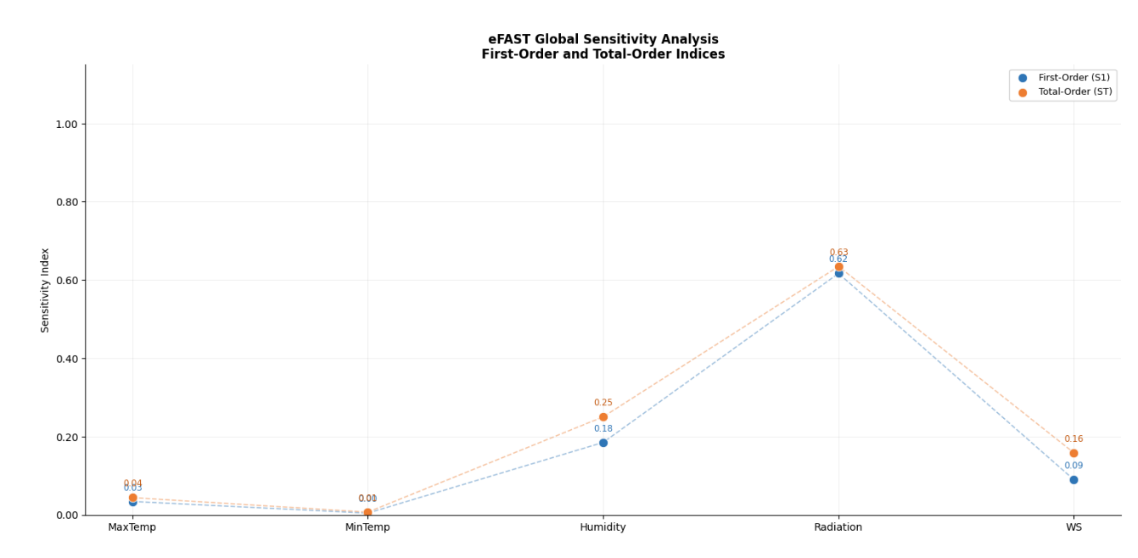
(a)
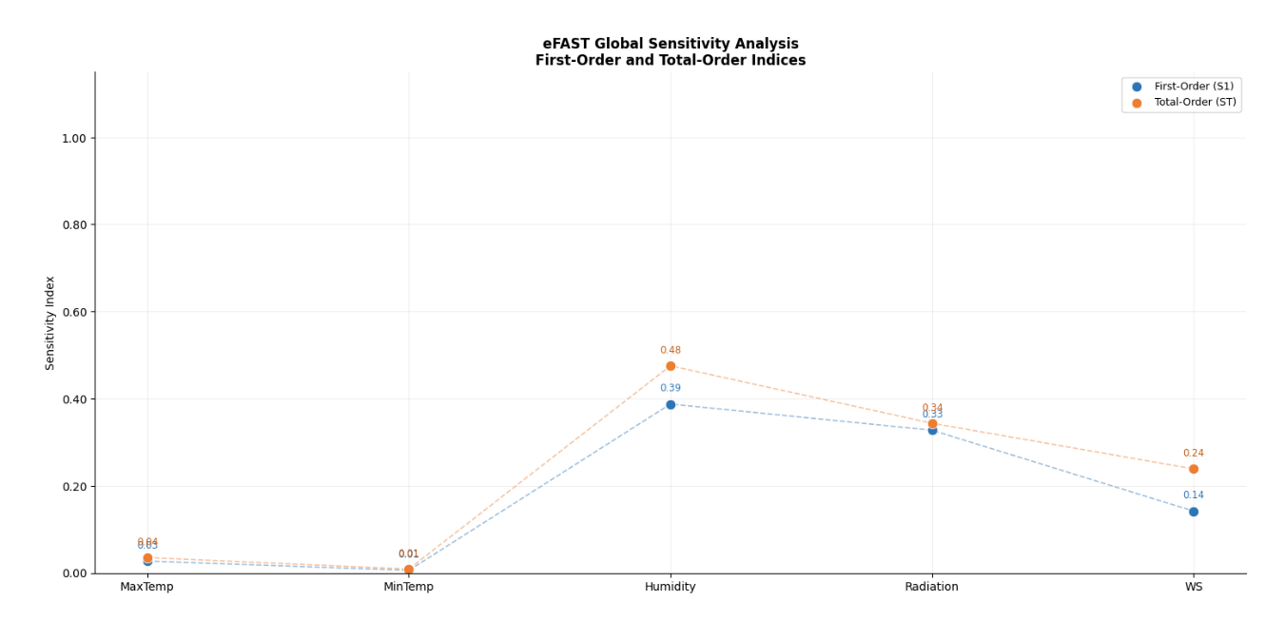
(b)
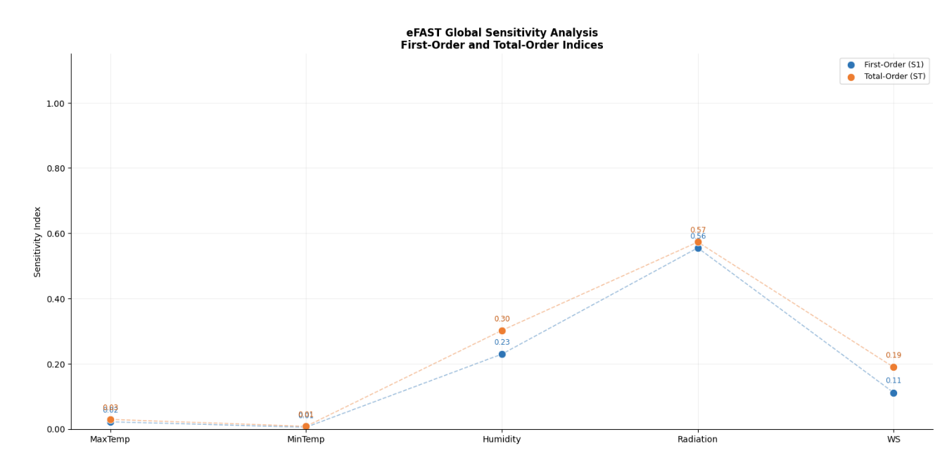
(c)
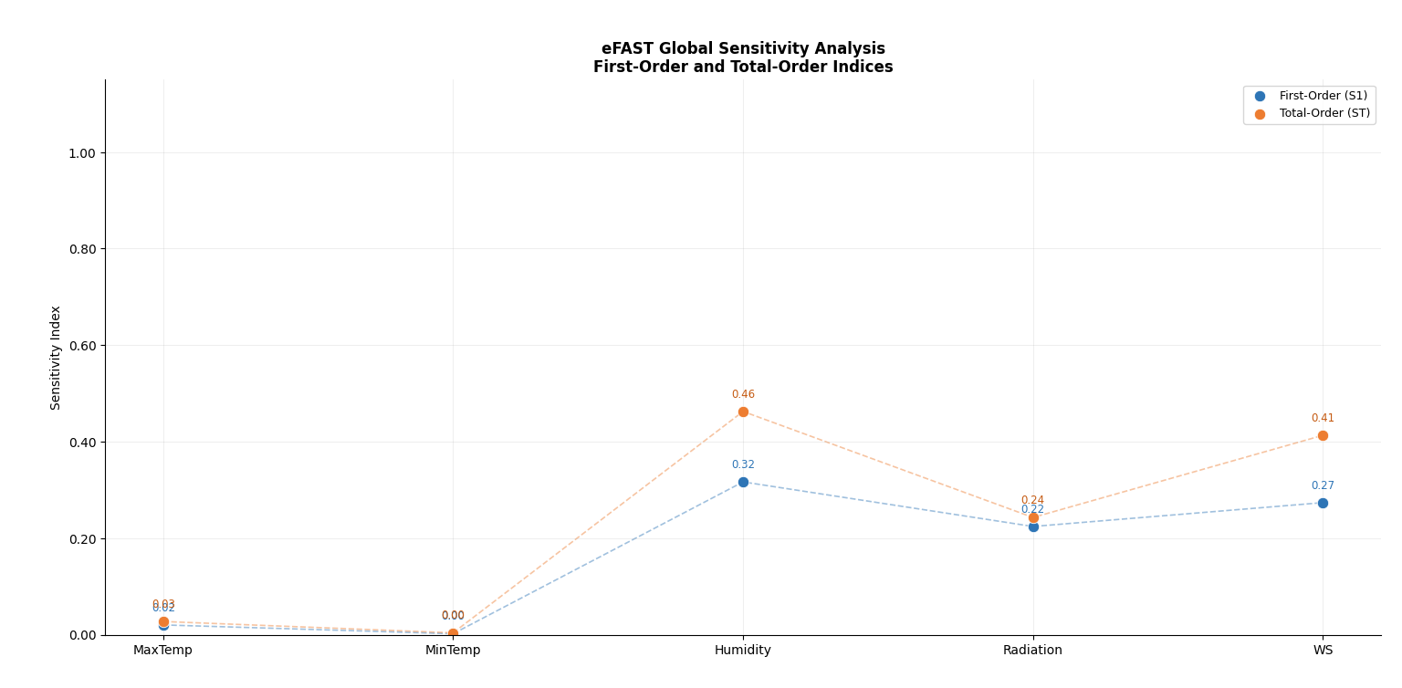
(d)
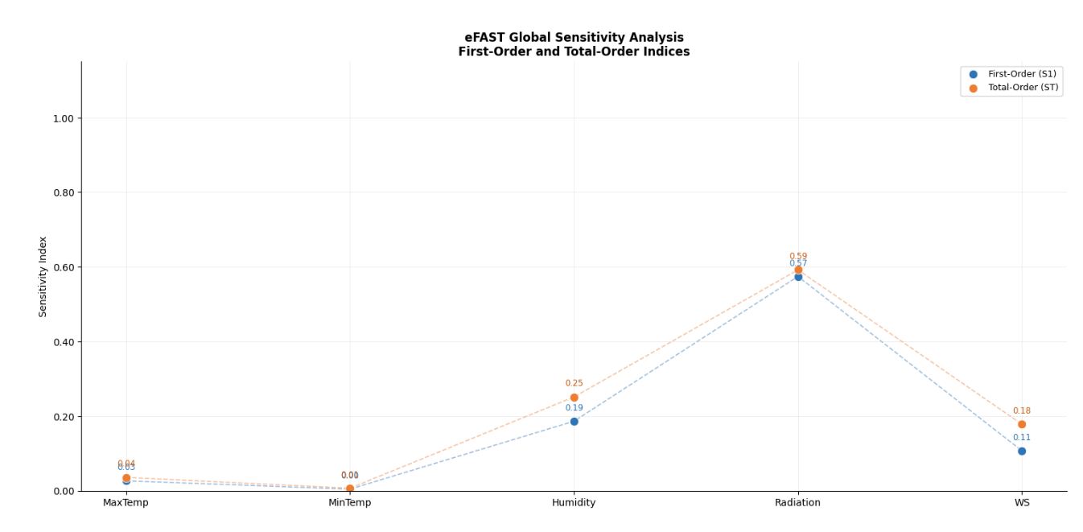
(e)
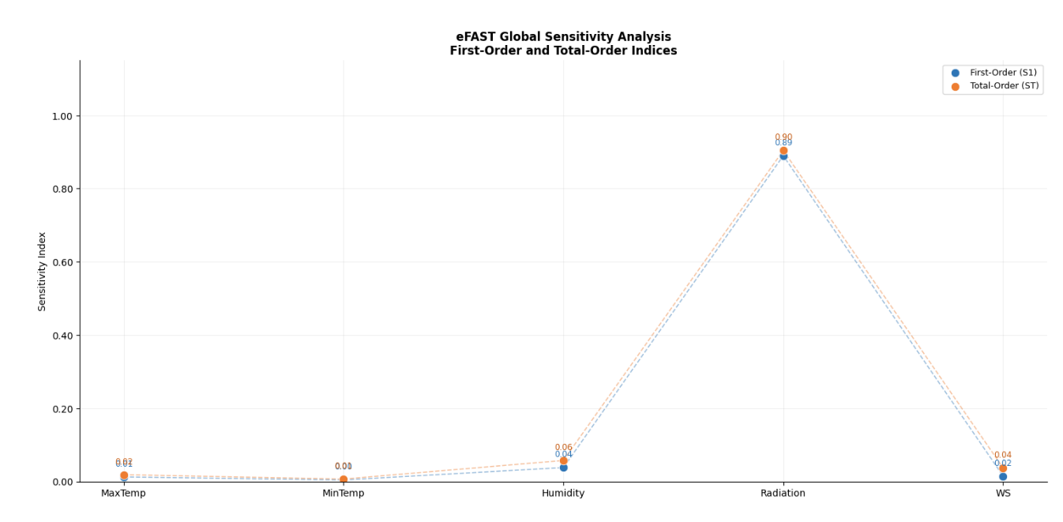
(f)
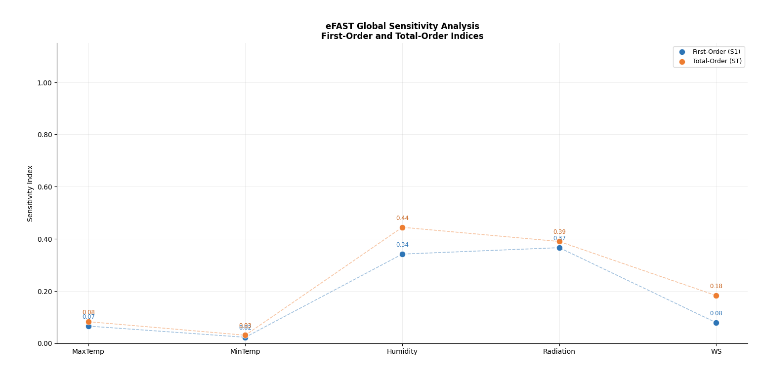
(g)
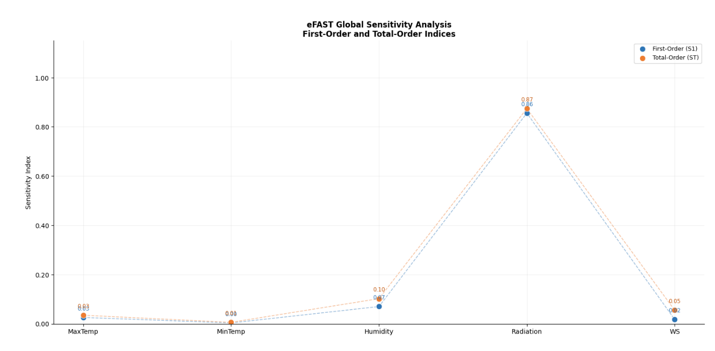
(h)
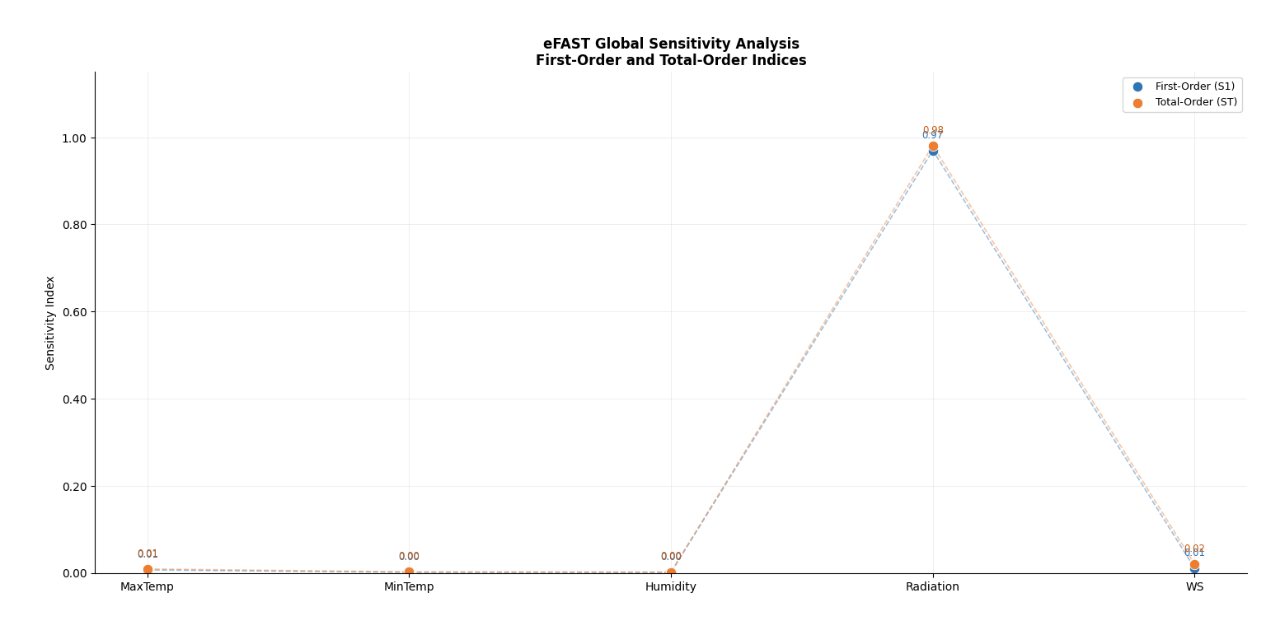
(i)
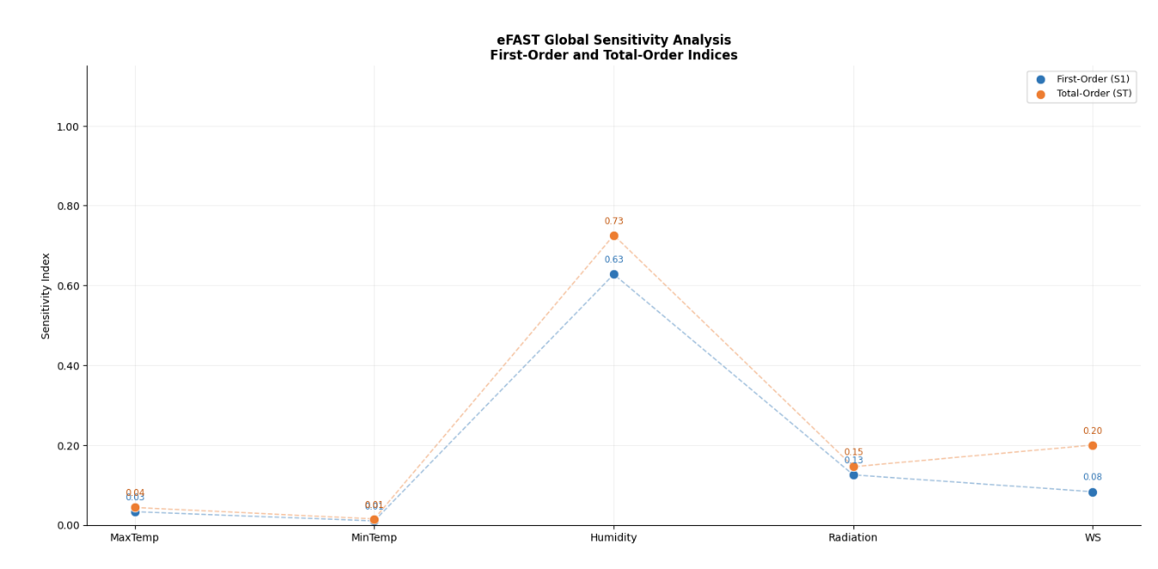
(j)
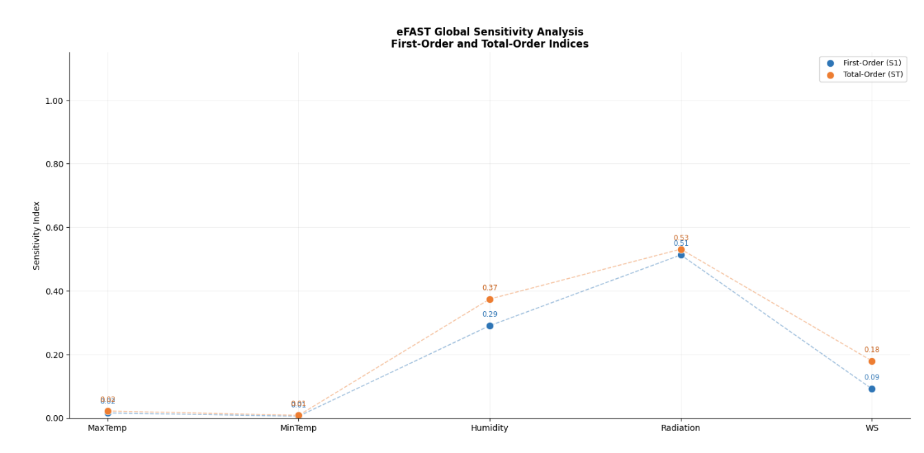
(k)
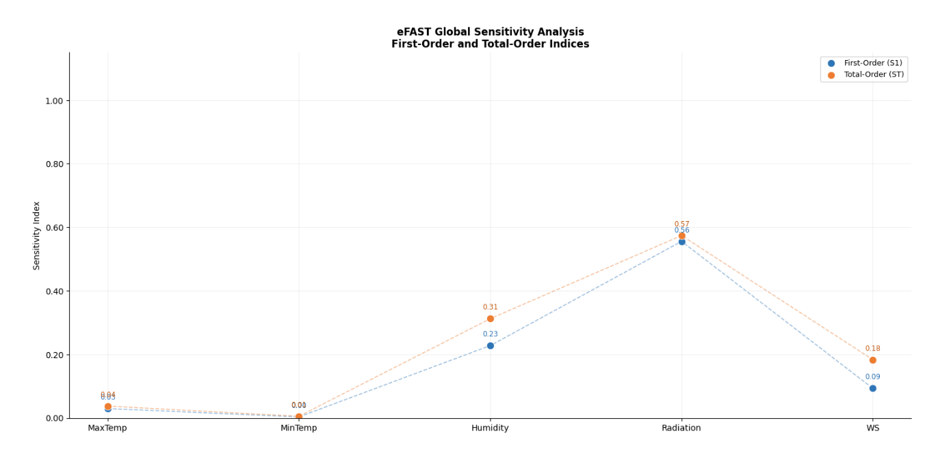
(l)
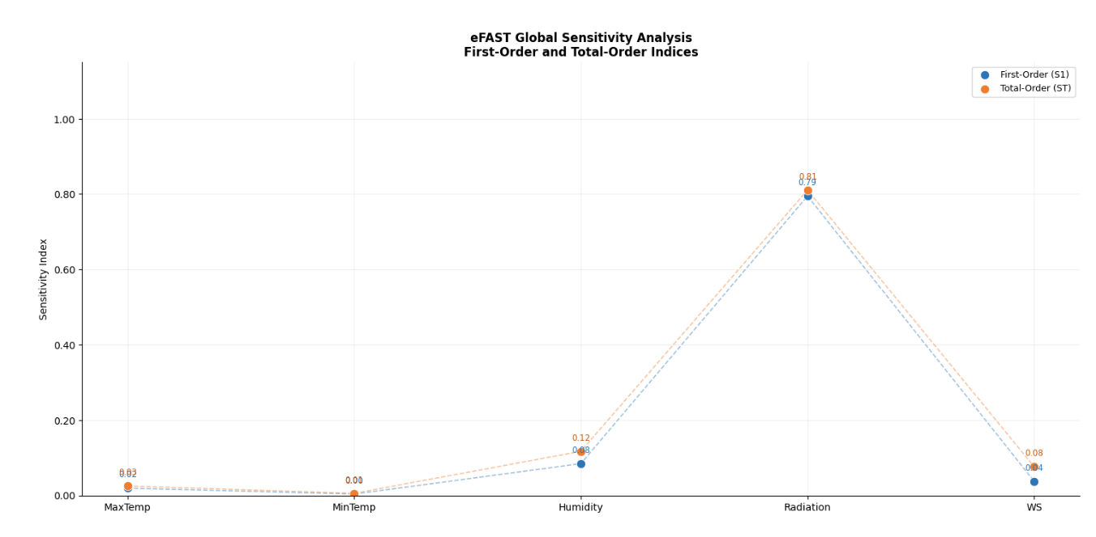
(m)
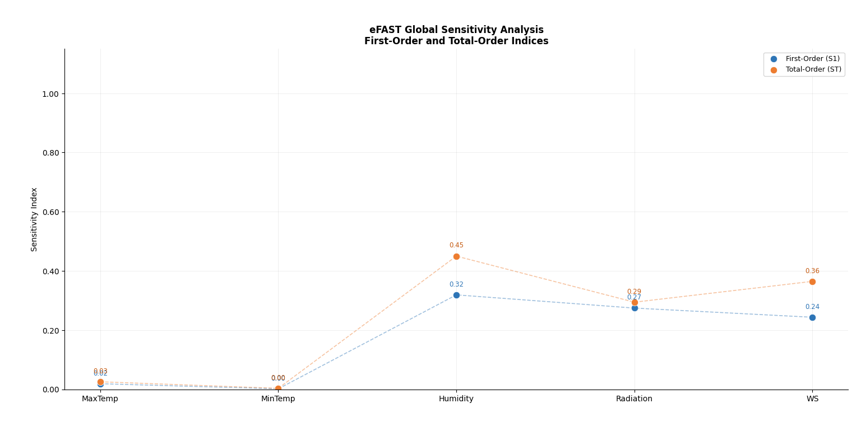
(n)
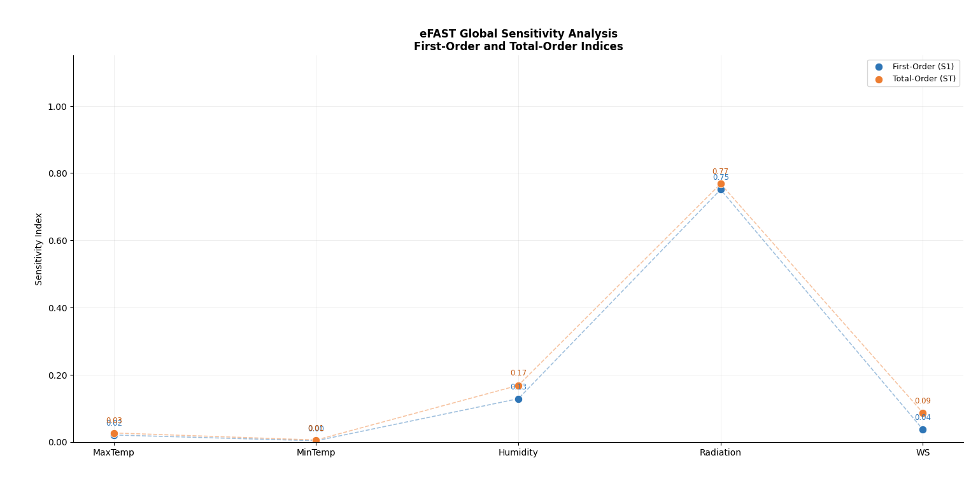
(o)
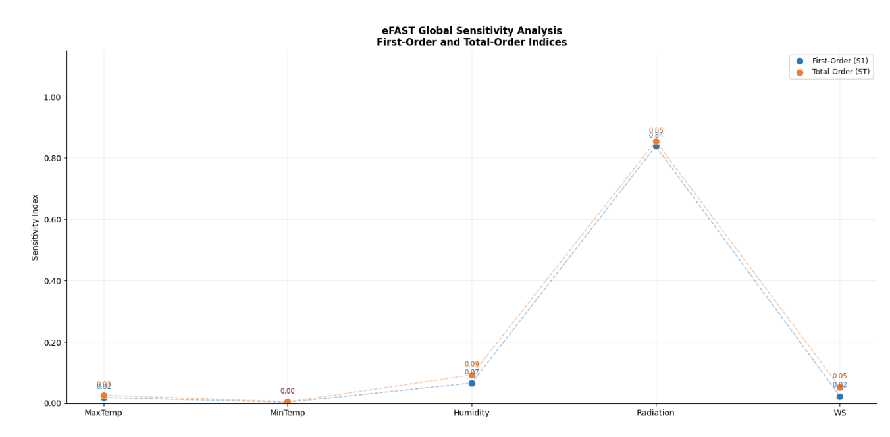
(p)
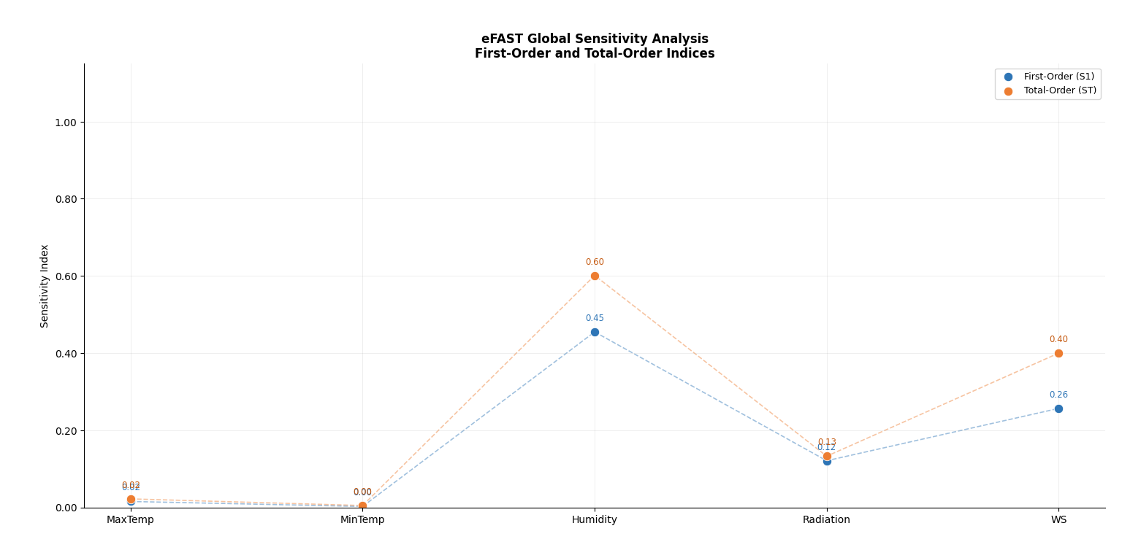
(q)
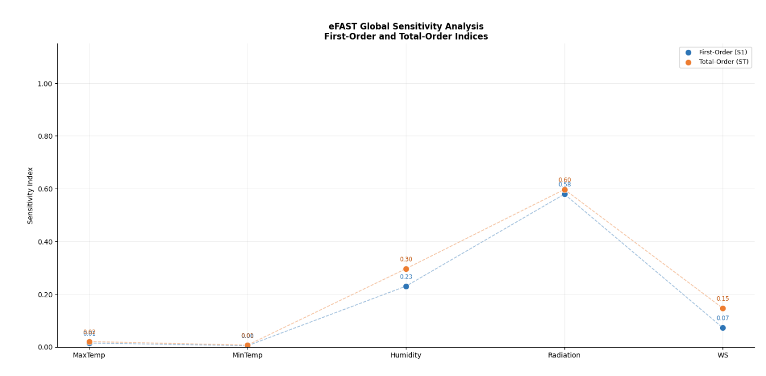
(r)
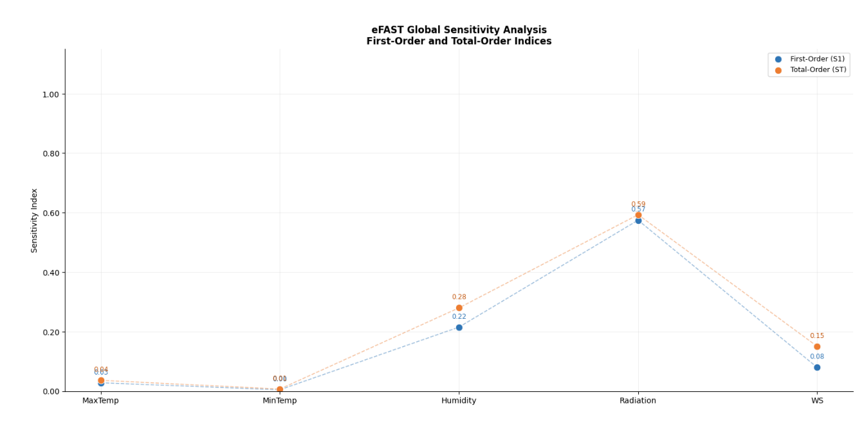
(s)
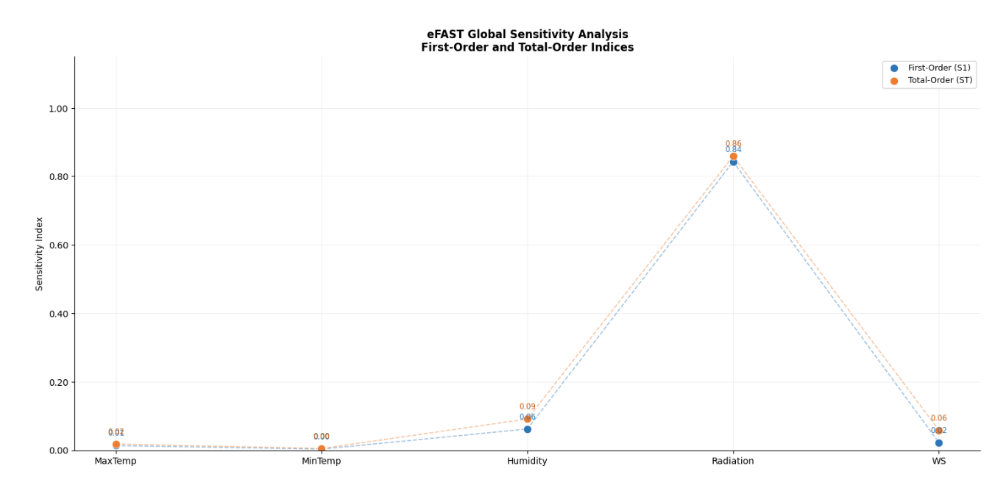
(t)

Fig. 2 Comparison of First-Order and Total-Order Sensitivity Indices for meteorological variables at the (a) Alor Setar, (b) Pulau Langkawi, (c) Bayan Lepas, (d) Ipoh, (e) Sitiawan, (f) Lubok Merbau, (g) Cameron Highlands, (h) Kuantan, (i) Muadzam Shah, (j) Kota Bahru, (k) Kuala Terengganu, (l) KLIA Sepang, (m) Subang, (n) Kuching, (o) Miri, (p) Sibu, (q) Sandakan, (r) Labuan, (s) Kota Kinabalu, (t) Tawau stations.

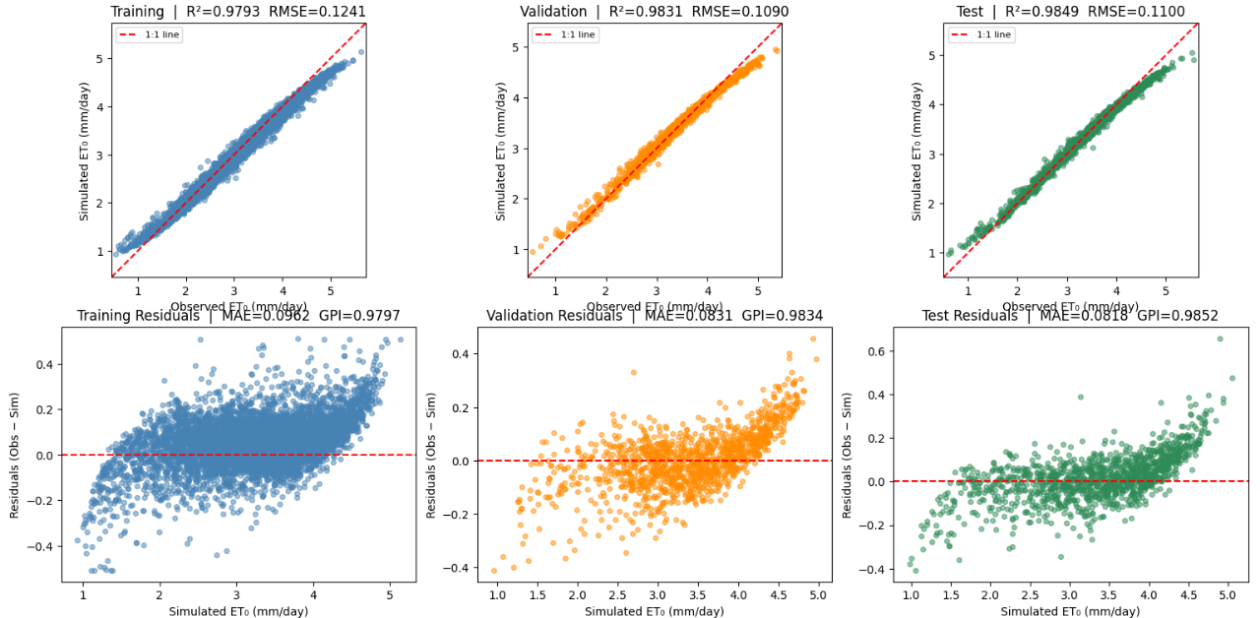
(a)

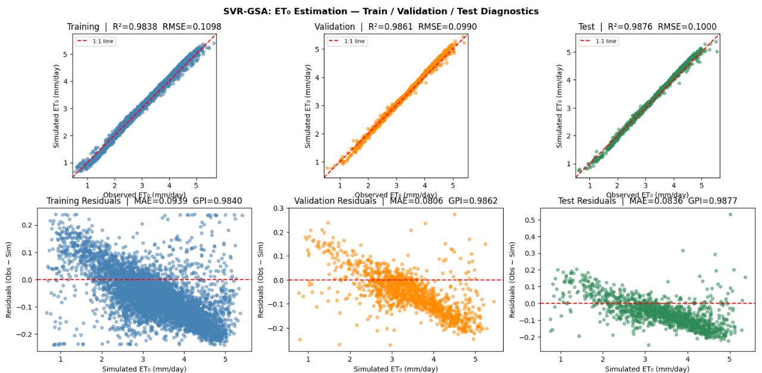
(b)

Fig. 3 Observed-versus-simulated ET₀ (top row) and residual diagnostics (bottom row) for the training, validation, and test subsets at Kuching station under the C4 input configuration for the (a) SVR-CMAES and (b) SVR-GSA model.

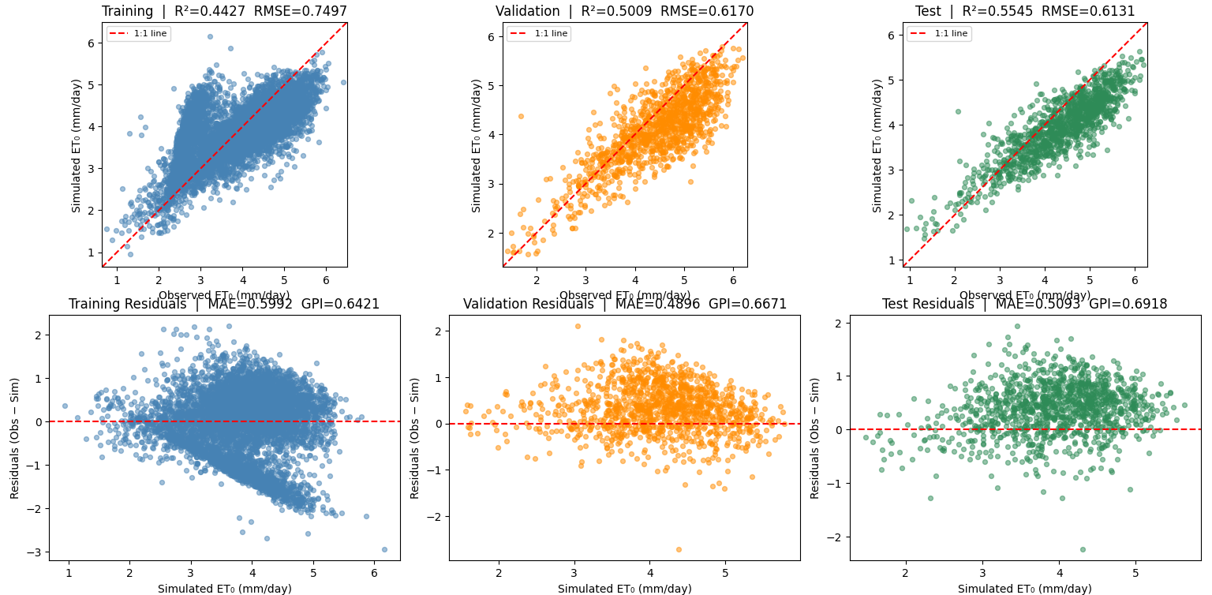
(a)

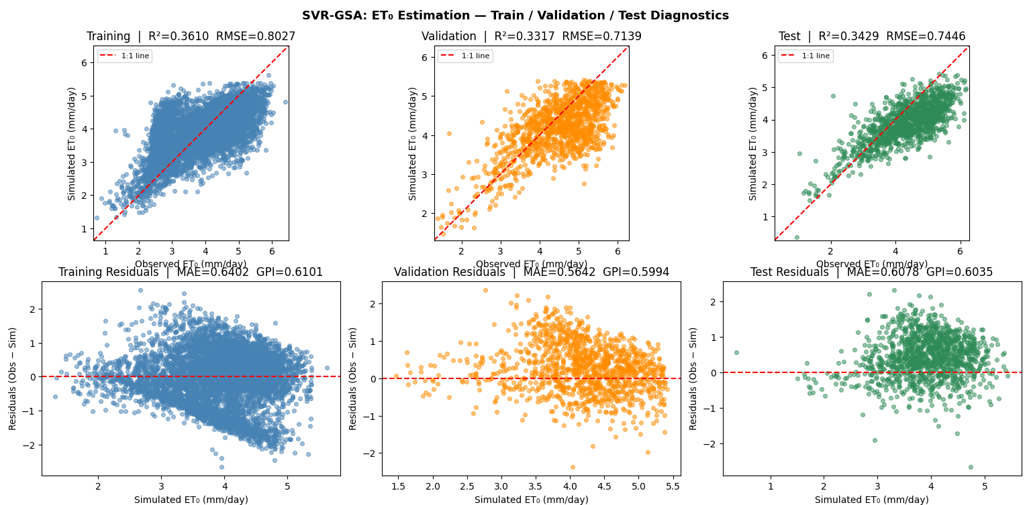
(b)

Fig. 4 Observed-versus-simulated ET₀ (top row) and residual diagnostics (bottom row) for the training, validation, and test subsets at Kota Kinabalu station under the C1 input configuration for the (a) SVR-CMAES and (b) SVR-GSA model.

